By Miranda by Nevaeh L.
Although the eleven other months are interesting, October is the most interesting to me! I say this because a lot of events go on during this month. The holiday that most kids love, because they get candy, is Halloween! During October it is also adopt a sheltered dog month. According to the ASPCA at least 12 million go to shelters so this is a big deal! Also, another event going on is Breast Cancer Awareness Month. Every body has their own culture, but in October we can celebrate our art and humanities. Since the weather’s been changing, a nice big bowl of chili is comfortable because it’s Chili month! Toys for Tots have been giving bones to pets for Wishbones for Pets since 2004 in this month! Last, October has not always been the tenth month of the year. At one time it was the 8th months of the year! It was switched with August. Clearly, October is a pretty interesting month!
During the week of September 9th, Colorado had record breaking heavy rain. Some areas got 9 to 20 inches of rain. The rain caused heavy catastrophic flooding in 14 counties. Some of the counties were: Boulder, Broomfield, Denver, and Weld. In fact, the flood reached over 200 miles of Colorado land. The rain happened when a cold front moved over the area. Governor Hickenlooper declared a state of emergency! Some oil and gas wells were shut down because of leaks. This could affect other people because there is less gas available. How can people drive to work without gas?! Farms were also flooded. This is dangerous because most of the food that we eat is grown or raised on farms. Finally, the flood affected tourism. Tourism is when people go visit a place. You can’t go somewhere when it’s flooded! Clearly, the flood caused a mess of problems for Colorado

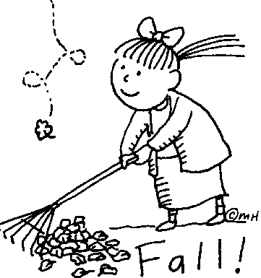

By Nevaeh P.
In September, the first Sumatran Tiger was born in London for the last 17 years! In 2008 Sumatran tigers were classified as critically endangered species by the IUCNC (International Union for the Conservation of Nature). They were named after an island called Sumatra in Western Indonesia. Sumatran tigers are endangered because their forests are being cut down, and they don’t have enough prey to feed on. They are being hunted by humans, and there’s only 400 left of the Sumatran tiger! All in all, I think we have to save our endangered species! The world has to work harder to keep the Sumatran tigers from going extinct!

