By Nevaeh L. by Ethan C.
Hypnotists by Gordon Korman
Hypnotists by Gordon Korman describes how a boy fights a doctor to stop him from taking over the United States of America. In the beginning, he hypnotizes his friends and is sent to a place named Sentia. After that, the boy works on his powers so that they are stronger. In the middle, he fights the doctor and wins. Immediately, the doctor hypnotizes the boy to fall off a seventeenth story balcony! Read this book NOW for a fast, fun, and mind-blowingly interesting adventure! Gordon Korman brings a great book; read it before it’s gone!
Although there are very interesting things going on around Colorado, this is what I found close to my heart. To begin, last year a girl my age was kidnapped. Jessica was kidnapped in Westminster at a park. When the police found her she had already passed away. Now, in memory of Jessica they built a new park where she was kidnapped. It was built with her favorite color, purple and it’s named after her! From what the old park looked like, this one is way better! Last but not least, as night the park is magnificent. At night it has lights but there are not ordinary lights, they are purple. Those lights also shine on a statue. The statue is made of metal and it has two butterflies. When the lights shine it looks glamorous. Clearly this is like a dream park!

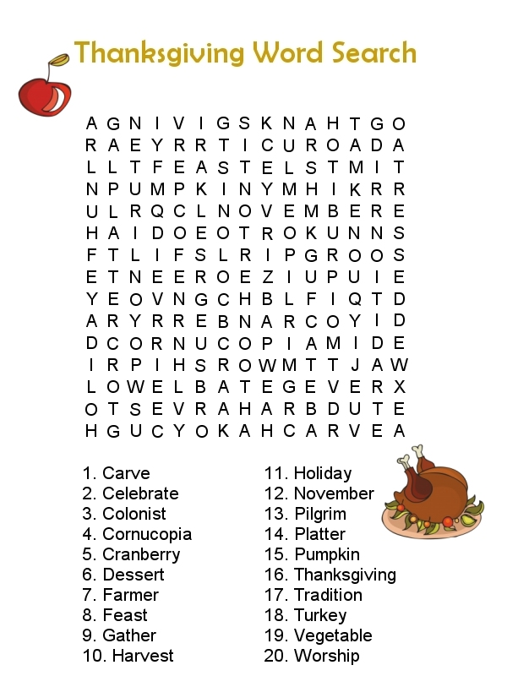

By Miranda S.
Each year, the Nobel prize committee gives out awards in six different categories, one of which is literature. This year, Alice Munro won the literature award. Alice is a Canadian woman who usually writes short stories. The prizes were given out October 7th – 12th, 2013. Alice wanted to be a writer from when she was a teenager. She helped her husband with a book store while raising their three daughters. She was named, “The Original Short Story Writer.” The award is given through the Novel Prize Committee located in Swededn. Alice is 82 years old and has written 14 story collections. This is important to our world because other writer’s get inspired by Alice’s work! She made sure that everyone knew that this was a work of art, and she was not just playing around. Clearly, Alice Munro is a truly transcendent writer!

