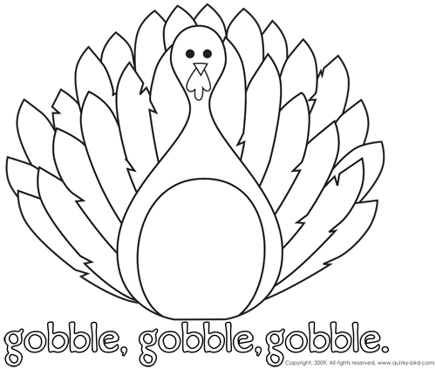

By Javier C.
November has lots of interesting facts! November is Peanut Butter Lover’s moth and November’s birthstone is Topaz! Harvest is this month so the winter is coming! I think this is an interesting fact that in November 1922 King Tut’s tomb was found with gold by English explorers! Can you believe this? A dog named Loaika was the first living creature to go into space (in November)! November 1st is Saint’s Day, where people follow God’s calls. On the 4th it’s Mischief Night where people put things in the wrong places. Don’t forget to vote on November 5th, it’s Election Day! The 11th is Veteran’s Day, so make sure to honor the army! Last but not least, I can’t wait for the best part of November- Thanksgiving! I get to eat turkey on November 28th!

By Cameron L.
A man robbed Public Service Credit Union in Brighton, Colorado at 145 South Kuner Road. Andrew Michael White is the suspect of the robbery and it happened at a local Check Into Cash. Andrew arrived in a Jeep on Friday, September 27th, 2013. People have to watch their stores so more robberies do not happen. There have been a lot of robberies in the USA. Already most of the United States has been robbed for this year, 2013. The police are getting really busy now. On Sunday night, the 20th, police were trying to get into a house. The people inside hit a car then ran away! As you can see, robberies are serious!!

By Lynzie M.
Even though a lot of things happened in the US, I’m only going to pick three things. To begin, on Monday, September 7th, 2013 in Alburaury, NM, there was a hot air balloon that caught on fire! The people in the hot air balloon are fine now. Also, the Cowboys and Eagles played a game of football and the Cowboys won the game. I bet that the fans of the Cowboys are very excited. Finally, the Broncos lost a game and all the Bronco fans are disappointed that the Broncos lost. All in all, those are some things that are happening in the United States!

By Justin
Star Wars: Jedi Academy by Jeffrey Brown
This book is about a boy named Roan Novachez who wanted to go to pilot academy but ended up going to Jedi Academy! Roan made friends when he got off the bus- their names are Pasha, Bill, Tegan, Gaiana, and Egon. The only problem is Roan doesn’t know how to use the force! Roan and his friends have to deal with three bullies named Cyrus, Cronan and Jo-Ann. Roan and his friends find interesting ways to out-smart the bullies. All the characters in the book are hilarious but Kitmum takes the cake! Overall, I think Jedi Academy is a great book!

