By Reygan G. by Emilio O.
- The flower symbols of January are the snowdrop and the carnation!
- On January 4, 1778, New Mexico became the 47th state in the United States.
- “Common Sense” by Thomas Paine was published on January 10th, 1776.
- Believe it or not, Elvis Presley’s birthday was on January 8th!
- On a normal day, an asteroid passed by Earth in January of 2013!
- In January 1967, PBS became the 70th television network.
- It’s also known that January is the national blood donor month!
- Did you know that January 26 is National Republic day in India?
- The word January in French is Janvier!
- Last but not least, the first day of January is Handsel Monday in Scotland and Northern England. It’s a day where servants give people gifts and tokens like on Christmas!
Recently, Fort Lupton High School’s football program has been stepping up the competition to get recognized by the Colorado High School Activities Association (aka the CHSAA) football committee where they are to determine whether Fort Lupton will remain as a 2A team or be elected to move to the 3A division. What does this mean for the Fort Lupton Blue Devils and their fans? Higher competition, high intensity play and the recognition of rankings are what we can expect from the change. This decision will be made sometime this month. The anticipation will be great!

By Logan L.
Catching Fire
By Suzanne Collins
You’re in for a surprise with the book Catching Fire. It has so many twists and turns leaving your jaw wide open! In the first book, The Hunger Games, Katniss and Peeta were chosen to compete in the games. The games are the government’s way of putting people in a death fight. In Catching Fire, their nightmare of being chosen again turns into a horror! Except this time they’re prepared- but are they ready for the competition, action, and the sacrifices? The government is actually trying to make these games the most challenging games ever, almost killing Katniss three times! The ending will leave your brain in knots! Find this outstanding book in your exclusive library!

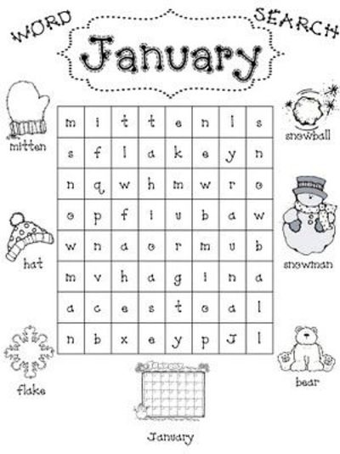

Find these words in the January Word Search:

mitten
hat
flake
January
snowman
snowball
bear

By Isabell S. by Camden G.

Don’t Shoot!
Claire Davis was a 17 year old senior at Arapahoe High School who died on December 21st, 2013. She was shot by another student. Sherriff Robinson identified the shooter as 18 year old Karl Halverson Pierson who killed himself after opening fire in the school. This shouldn’t happen to people, but it does. Hopefully we can do something to be rid of this type of problem soon!
On December 23rd, 2013 there was a man collecting donations for charity and one very generous woman donated a diamond ring worth $3,500 dollars! She has actually done this four times and left a note but didn’t take any credit! This one time she donated a gold nugget worth $4,000, and then she donated another diamond ring and then $1,000! I am sure the charity appreciated that very much.
Also on January 5th, 2014, a small plane crashed while trying to land in Aspen, Colorado. The copilot was killed while two others were severely injured. This crash happened because there were very high winds and while the plan was trying to land it tipped over and was engulfed in flames. It was a very tragic accident.

By Jesus D.
Stick Dog
By Tom Watson
Do you like books with Dalmatians and nick names like Poo-Poo? Also with really bad pictures? Then Stick Dog by Tom Watson is the book you’re looking for. Now, do you love it when dogs are looking for something? Well that is what this book is about. The five friends Poo-Poo, Stripes, Karen, Mutt and Stick Dog have to outsmart the humans for what they want. Karen’s thought was to take the human’s keys and go for a joyride! The Stripes was a police dog but thought of the dumbest idea. His idea was making Stick Dog fly! If you want a book to make you laugh, Stick Dog will be a perfect choice for you!

By Jovahn M.
January is going to be a busy month! In Math, fourth grade will be working on perimeters and area, which is a part of geometry and measurement. In reading, we will be learning poetry. We will be reading Love that Dog by Sharon Creech. The teachers are planning on doing a poetry smash at the end of the month where parents and grandparents are invited to attend and hear our poetry!! In writing, we will be writing poems as well. Poems are short stories that often rhyme! In social studies, fourth grade will be learning about westward expansion and finding gold in Colorado! Access testing will begin for our ESL students in January – good luck everyone! In our Art class, fourth graders will be making clay mugs that will look similar to the ones Native Americans made. This is going to be a great month for fourth graders!!

Don’t forget, Martin Luther King Jr Day is on Mon.
January 20th, so we will have no school. Spend a little
time this month thinking about all the good things
in life that we are grateful for!

