By Reygan G. by Logan
In the United States, a 19 year old woman was recently shot. She was not shot at close range. The police are still looking for the repulsive suspect, wondering why he or she would do such a thing. Right now they are still looking for more information. Once they find enough information, they might know why they did it and maybe even who did it! If they find the suspect, they’ll bring them to prison for their whole life. The police are guessing the woman was shot by a sniper. It depends on the weapon to decide what the charges are. Hopefully, the police will find whoever shot this poor, innocent, young woman and bring them to justice. Nothing this sad should happen!
What would you do if you discovered a mystery that was so unnerving that no one would believe you? Creep Over: Truth or Dare by P.J. Night takes place in a small town where Abby Miller and a few of her friends experience unexplained events with secret notes received in the middle of the night that only her close friends know about! Jake asked her to the school dance, but as the night of the school dance comes closer, some very creepy things start happening to Abby! Someone or something seems to want to keep her away from Jake. Is it a jealous classmate or, as Abby begins to suspect, a ghost? This mystery is a good way to stay entertained and on your toes, making you want to read more, as you won’t know what happens next! If you haven’t read this book before, this is a must-read!

By Jesus D.

The state of Colorado has declared that instead of 4th grade standards, they will automatically switch to common core standards. Now students will do something they don’t know! 4th graders have been reading about a book that kids have to dig holes but they’re digging in the wrong place. Will they find what they were looking for? In writing we are writing about how it would feel if they were in the book students are reading. How many holes will they dig per day? Or worse, where will they dig? In science we are learning about food chains and food webs. People have been saying that we’re on top of the food chains – is that true or false? 4th grade and the whole school are doing a canned food drive so we can help people in need. Another thing we are doing is dividing by two digits. 4th grade is really up to the challenge!!
By Jovahn
On November 8, 2013 a deadly typhoon hit the Philippines. There were many people who died and survivors going to the hospitals. None of the hospitals had electricity. There were three aircraft carriers that provided food and water to the helpless. The carriers’ names are the USS George Washington, the USS Mercy, and the HMS Illustrious. The USS George Washington and the USS Mercy are American aircraft carriers. The HMS Illustrious is a British Aircraft carrier. This typhoon will take years to clean up. It will take a long time to clean up because everybody’s houses will be demolished. This is one dangerous natural disaster! A tornado or hurricane isn’t as deadly as this typhoon!

By Camden G. By Isabell S.
December has lots of interesting facts! The name December comes from the Latin word decem for ten, as it was the 10th month in the Roman calendar. That’s weird because it’s the twelfth month for us! December has three birthstones: lapis lazuli, turquoise, and zircon. The birth flower of December is the narcissus. On December 3rd, 1907 the first heart transplant was completed. On December 7th, 1941, the United States Naval Base Pearl Harbor was attacked by Japanese planes which killed more than 2,300 Americans. On December 31st it’s New Year’s Eve, that means it’s almost 2014! Last but not least, the best part of December? CHRISTMAS!!
One morning on November 19, 2013 there was a middle schooler walking across the street and was hit by a car! Miraculously, he was fine! The accident occurred at Vindicator and Rockrimmon. The accident was also near Eagleview Middle School and it is unknown if he was a student there. You should always be safe near the road!
Also, on December 3rd, 2013 around 5pm, the police and SWAT team surrounded an apartment complex searching for a wanted man. The police haven’t reported much but they might be going after him in one of the apartment buildings. If you do bad things, the police will catch you!

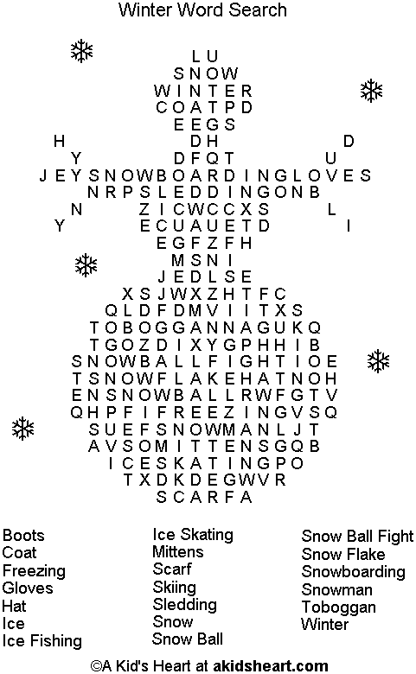

By Emilio O.
Title: Scary Stories to Tell in the Dark
To begin, Scary Stories to Tell in the Dark by Alvin Schwartz is an amazing horror book. The first time I read the book I was amazed! The scary stories seemed as if they all really happened! One of the stories nearly made me stay up the entire night. Some of the chapters contain action and mystery. Most of these chapters will make your heart drop. A few others will leave you with a mysterious ending. Most of the stories are about punishment. If a character did something wrong they get left with a chilling surprise. All in all, this book would be amazing to read—I recommend it!

